08/07/2021
A startup involved in the financial domain has hiredyou as "Chief Anti-Fraud Officier." Unfortunately, the company has no historical data related to previous frauds or legitimate transactions. However, it recently hired some expert fraud analysts as part of your team. Your primary task is to design an effective anti-fraudstrategy.
- By considering the scenario described above, explain which type of techniques and/or system you would deploy, providing a brief explanation of how they work, the order of deployment, and their advantages and disadvantages.
- After a few days, the company is the victim of a fraudulent campaign. Therefore, you decide to analyze available data. Considering only the graph shown below, which shows the distribution of the amount spent percountry by a customer, explain the analysis you would apply on that data and what are the first insights you can extract from it.
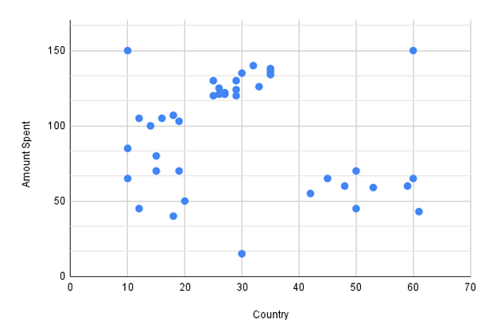
- Base some starting information from experts observation to start having rules to use to detect and distinguish fraudolent and non fraudolent transactions. They will provide a “supervised-like” environment from which to start
- A recognizable pattern we can observe here it that users in specific country are likely to spend the same amount of time. Having enough data and detecting a certain “pattern”, peer groups analysis can be applied. Clustering is an ideal procedure too, as we’ll split all the set of observation in groups so that for each gropu we have maximize the “internal homogeneity” and we maximize the differences among separated clusters.

08/07/2021
A startup involved in the financial domain has hiredyou as "Chief Anti-Fraud Officer." The company has collected at least two years of historical data related to previous frauds and legitimate transactions. Your primary task isto design an effective anti-fraud solution.
- By considering the scenario describedabove, explain which type of techniques and/or system you would deploy, providinga brief explanation of how they work, the order of deployment, and their advantages anddisadvantages.
- After a few days, the company is the victim of a fraudulent campaign. Therefore, you decide to analyze available data. Considering the data contained in the table shown below, which shows the first rows of the currentdataset, explain the analysis you would apply on that data and what are the first insights you can extract from it.
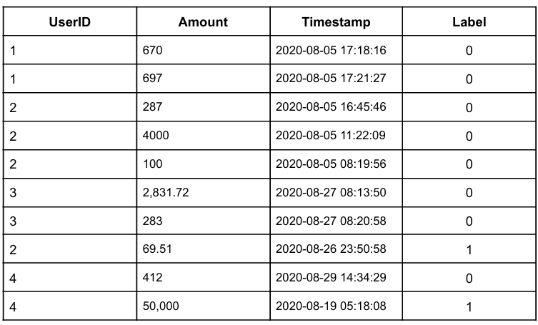
- Data collection, pre-processing, cleaning and model definition by means of a Supervised Learning ML technique. Advantages: … Disadvantages: Not able to detect novel models
More reasoning and interpetation on the contexr from which data were collected
- Pure, simple analysis of the insights and observations of NEW fraudolent attack; this answer is not related with the previous. Almost all the amounts are on the order of hundreds of euros. The one that goes to the order of miles are generally performed in the early morning. Attacks happens generally in the morning or in the ealy evening/night.
In this case of labeled, categorical data, we can perform classification analysis and use rule-extraction procedure to extract if-then classification rules.
In case they were not labeled, clustering, breakpoint analysis or peer group analysis Unsupervised model

